HSF Lapping Guide
Written By : Christopher McInnis
Mission: To lap/resurface your heat sink
Purpose: To even out the irregular surface of the heat sink; to reduce thermal resistance; to increase thermal conductivity
Cost(s): $2.99 (plus tax) for Wet/Dry sandpaper (spring for this stuff, it makes all the difference), piece of glass (got one out of a small picture frame), water, 15 minutes to 1 hour of free time.
CAUTION: Before beginning this procedure, completely remove your fan assembly and retaining clip. Failure to do so may result in the assembly shorting out. Also, before reassembling the HSF, Make certain that the heat sink is completely dry. (I’d recommend overnight). If not, it could short out the CPU and/or the motherboard. Be prepared to be at this a while – your heat sink may seem flat, but I assure you, it’s probably not!
Introduction
Alright kiddies, it’s time for a quick demonstration on how to properly lap a heat sink. Most heat sinks come with either a convex or concave bottom, which means that the surface is not making full contact with the die. In ye olden days of Pentiums and K5’s this wasn’t much of a problem. The die was humongous (OLD=half dollar, NEW-dime), the heat sinks were smaller, and power dissipation wasn’t really an issue (most early Pentiums were cooled by heat sink only and threw out a whopping 11.9 watts and rated for a max ambient temp of 80’C).
In a November 1995 white paper, Intel stated: “Higher Temperatures result in earlier failure of the devices in the system. Every 10’C rise above the operating temperature means a halving of the mean time between failures”
Now you know why it’s important, so let’s get to it. Gather up your supplies, roll up your sleeves and let’s start lapping.
Start by tearing your sandpaper into ¼’s. Begin with the roughest grit you have. In my case it was 220. Fold the paper over the glass like so:

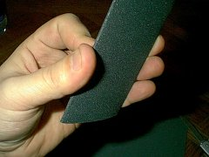
Click On Image To Enlarge
Next, I dipped the paper in a bowl of water (the reason why I sprang for wet/dry), shook off most of the excess and began lapping. I prefer this method to taping an entire sheet to a larger pane of glass and sprinkling it with water, as I feel I have more control over the work piece.
Next, let’s examine the surface.

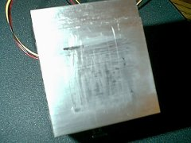
Click On Image To Enlarge
Look at this mess! Mine had some horrendous scratches on the base. This was partly my fault…I tried to scrape off some that god-awful thermal putty with a dull knife. I assure you though; this lapping would still be necessary even if I hadn’t gauged the heck out of the base -- as we’ll see after a few minutes of sanding.

Start in either a “figure 8” or circular motion begin to lightly sand the base of the heat sink. After several minutes, you will begin to notice that you are only sanding the outside edges of the heat sink and there doesn’t seem to be anything happening in the middle.

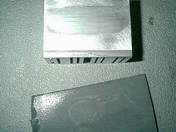
Click On Image To Enlarge
This is due to the extreme unevenness of the base (see I warned ya). Continue sanding with the 220 until you have removed any scratches and imperfections and have a uniform surface. You may need to change the paper at this point, but I didn’t worry as the pack of paper I purchased came with 2 sheets of 220 grit.

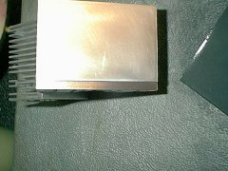
Click On Image To Enlarge

Continue this until you have moved through all the different grits – you will begin to notice that the grooves and imperfections will become less apparent. NOTE: If you change grits too early, this procedure may become more difficult. I have found it easier to use higher grits on a uniform surface as opposed to using the same grit on an uneven surface. Let the sandpaper do the work for you.
When you are finished, you will get a very smooth and shiny surface. At this point you may choose to go with an 800, 1000, or 1600 grit paper. In my case, I chose to stop at the 600 grit..…Looked good to me – no more deep grooves for air pockets and debris to hide.
As another option, you can polish the base with either a piece of notebook paper or a very fine polishing compound. I chose to leave it as is. Be sure to give a final washing in clean water to remove any Aluminum dust and sandpaper residue. Set on a paper towel and dry overnight. Next day be sure to wipe the base with some alcohol to remove any further reside, attach your retention clip, remount the fan assembly, apply your thermal paste of choice and remount the HSF to your ZIF.
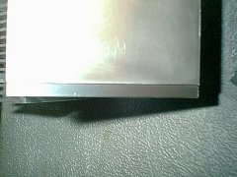
Click On Image To Enlarge
After I remounted my HSF, I managed to drop my load CPU temps 2’C and my idle temp by 3’C (you results may differ). Overall, this is a project I think every overclocker should do. The reduction in temperature may not give you any performance boost, but it sure can’t hurt your stability.

